Name: Saurabh Kadam

Roll No.: 47

Course: PGDACC (ESDS)

Subject: DBA

Project: Mini-Project on Database Creation, Table Creation and DML Operations

**Theory:**

1. **Database:**

A database is a separate application that stores a collection of data. Each database has one or more distinct APIs for creating, accessing, managing, searching and replicating the data it holds. Other kinds of data stores can also be used, such as files on the file system or large hash tables in memory but data fetching and writing would not be so fast and easy with those type of systems.

1. **MySQL**:-

MySQL is the most popular Open Source Relational SQL Database Management System. MySQL is one of the best RDBMS being used for developing various web-based software applications. MySQL is developed, marketed and supported by MySQL AB, which is a Swedish company. This tutorial will give you a quick start to MySQL and make you comfortable with MySQL programming.

1. **MySQL Database**

MySQL is a fast, easy-to-use RDBMS being used for many small and big businesses. MySQL is developed, marketed and supported by MySQL AB, which is a Swedish company. MySQL is becoming so popular because of many good reasons −

* MySQL is released under an open-source license. So you have nothing to pay to use it.
* MySQL is a very powerful program in its own right. It handles a large subset of the functionality of the most expensive and powerful database packages.
* MySQL uses a standard form of the well-known SQL data language.
* MySQL works on many operating systems and with many languages including PHP, PERL, C, C++, JAVA, etc.
* MySQL works very quickly and works well even with large data sets.
* MySQL is very friendly to PHP, the most appreciated language for web development.
* MySQL supports large databases, up to 50 million rows or more in a table. The default file size limit for a table is 4GB, but you can increase this (if your operating system can handle it) to a theoretical limit of 8 million terabytes (TB).
* MySQL is customizable. The open-source GPL license allows programmers to modify the MySQL software to fit their own specific environments.

1. **Database Creation:-**

To create a new database in MySQL, you use the CREATE DATABASE

Syntax:-

**CREATE** **DATABASE** [**IF** **NOT** **EXISTS**] database_name [CHARACTER **SET** charset_name] [**COLLATE** collation_name]

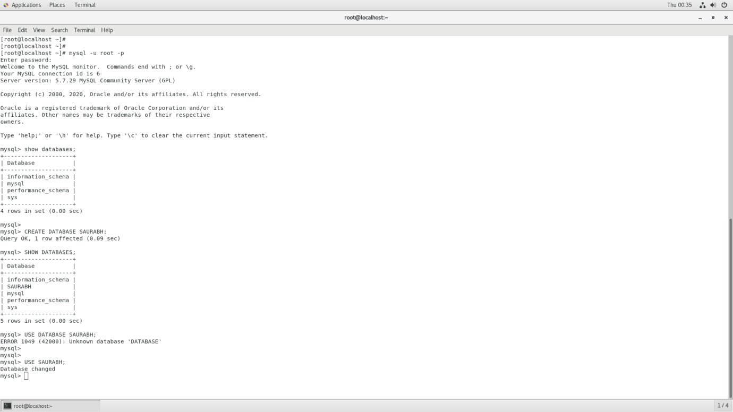

After that, if you want to review the created database, you can use the SHOW CREATE DATABASE command

Finally, to access the newly created database, you use the USE database command as follows:

Syntax:- USE DATABASE <DB_NAME>

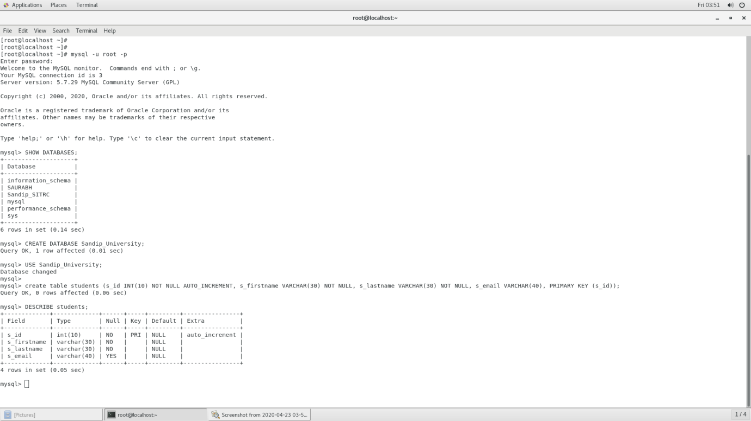

1. **Table Creation:-**

The CREATE TABLE statement allows you to create a new table in a database.

Syntax:-

**CREATE** **TABLE** [**IF** **NOT** **EXISTS**] table_name( column_1_definition, column_2_definition, ..., table_constraints )

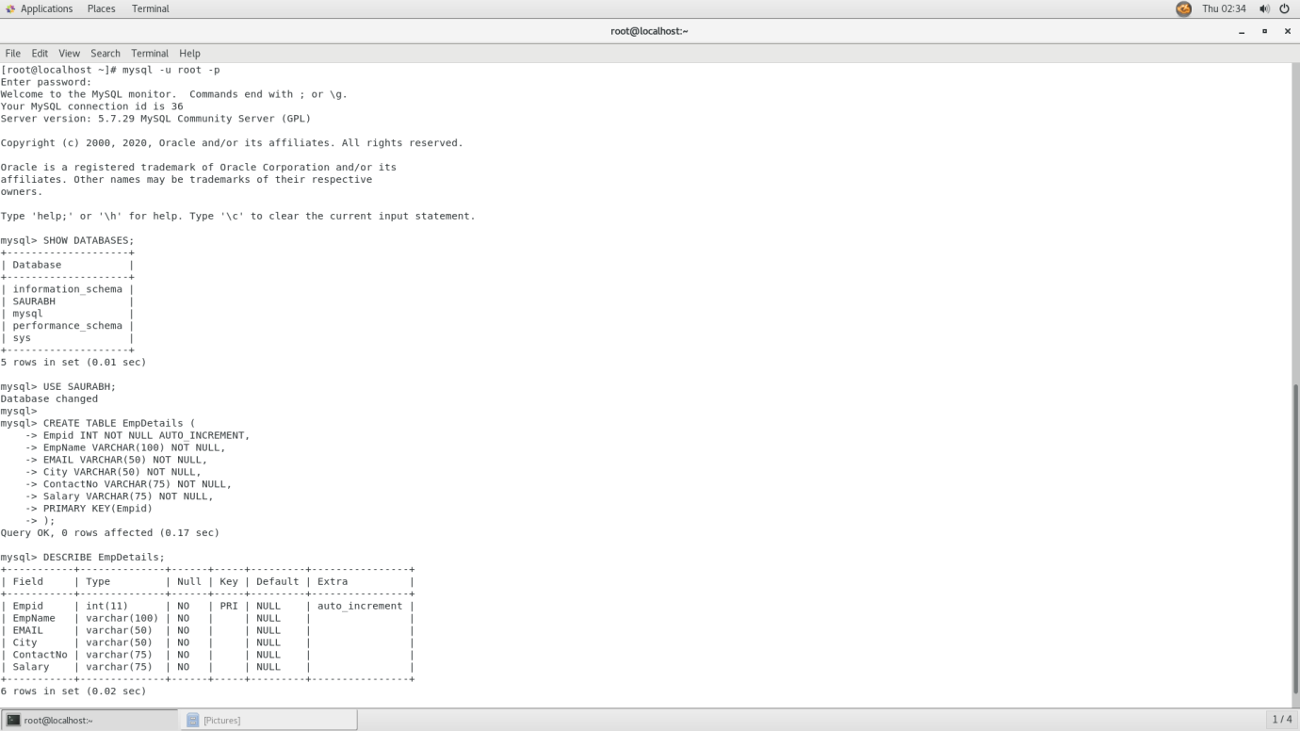

Once you execute the CREATE TABLE statement to create the tasks table, you can view its structure by using the DESCRIBE statement**:**

Syntax:-

DESCRIBE TABLE

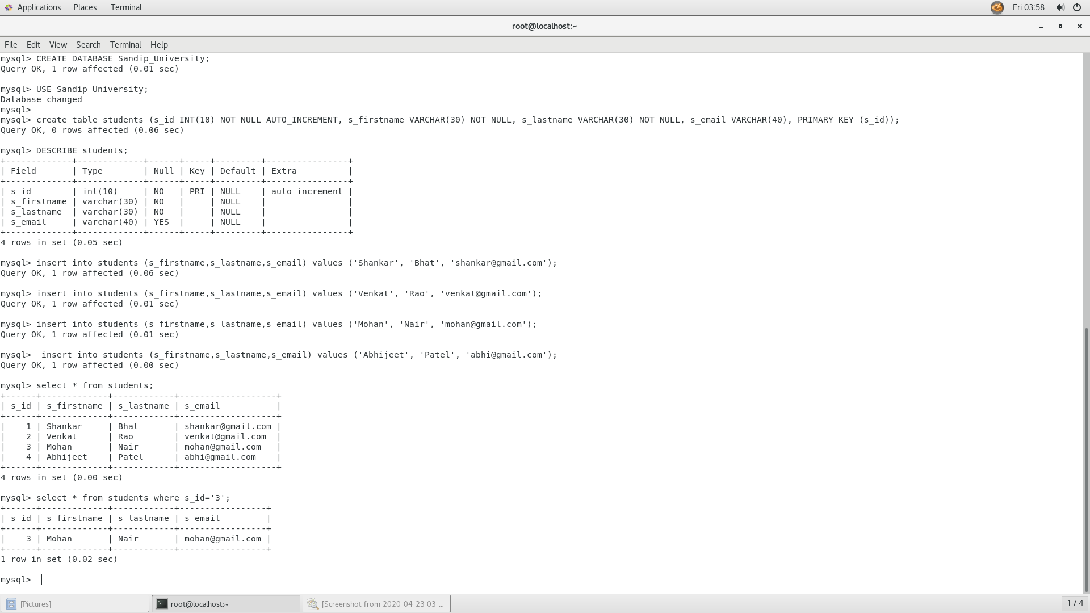

1. **Column Creation and Record Insertion:-**

The INSERT statement allows you to insert one or more rows into a table. The following illustrates the syntax of the INSERT statement:

Syntax:-

INSERT INTO table(c1,c2,...)

VALUES (v1,v2,...);

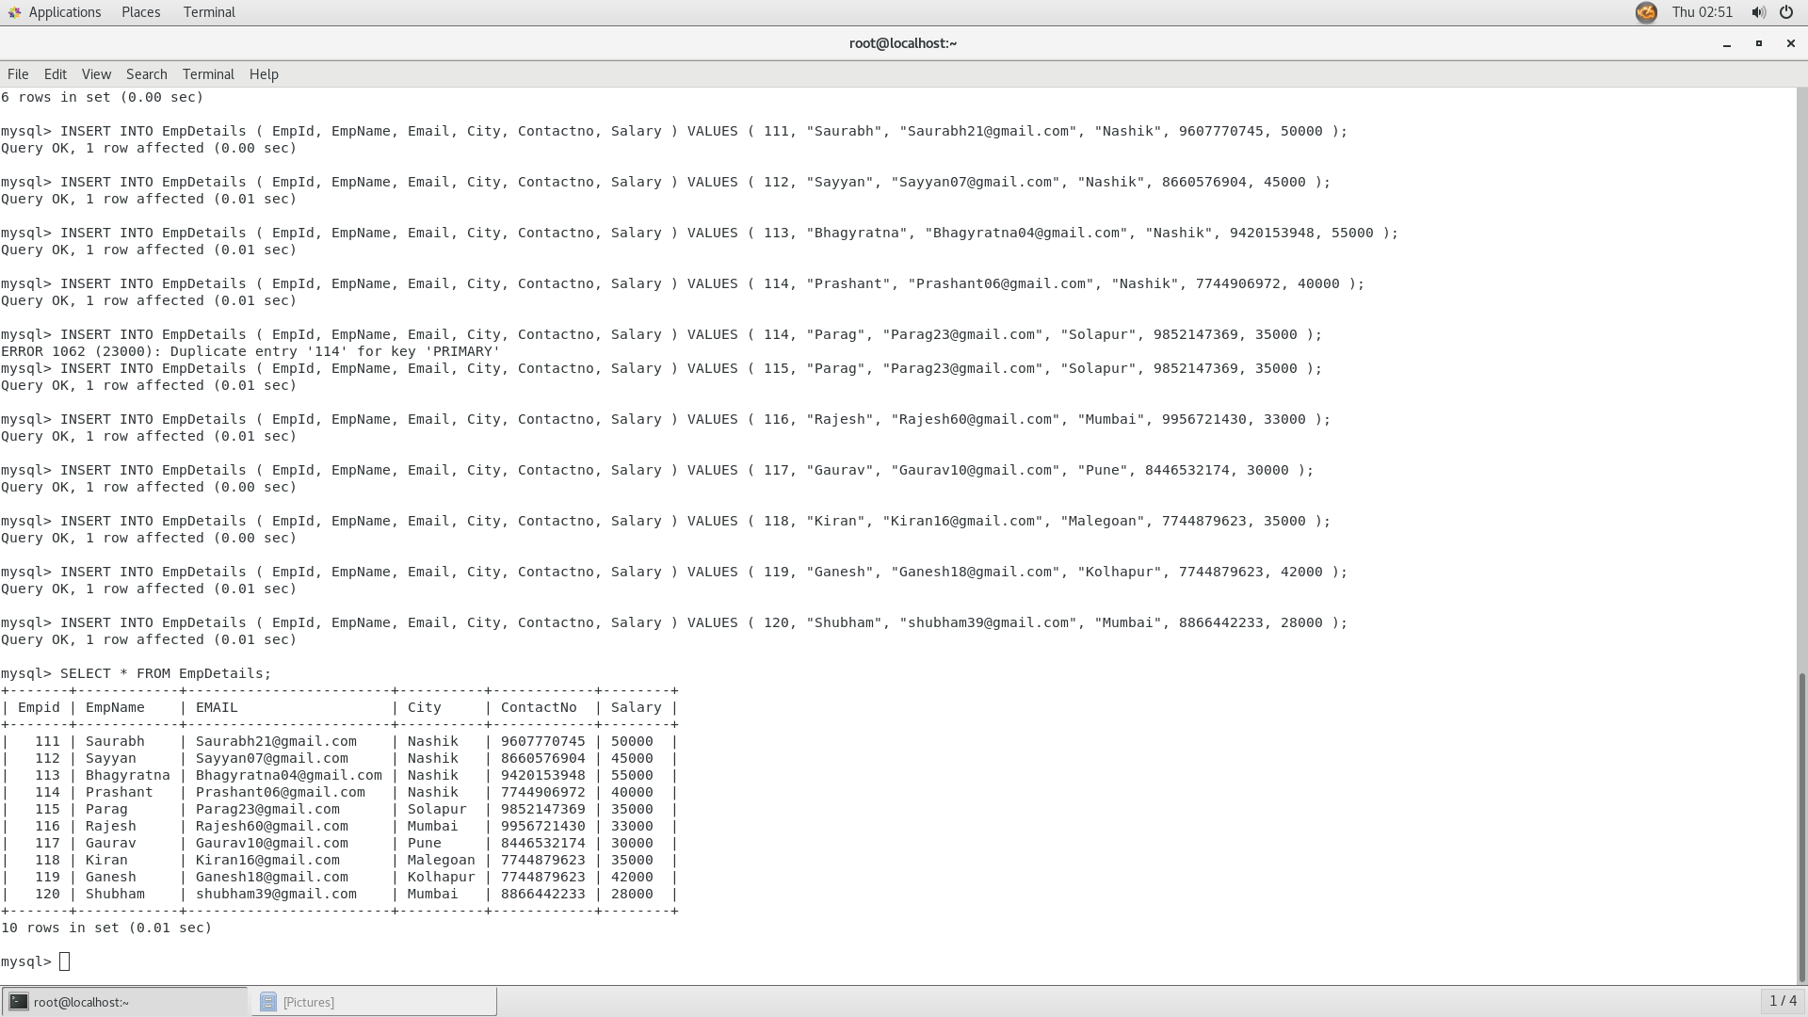

The following statement returns the contents of the table after the insert:

Syntax:-

SELECT * FROM TABLE_NAME



1. **Perform basic DML operation like :**

**1) Insert:-**

MySQL INSERT statement is used to insert data in MySQL table within the database. We can insert single or multiple records using a single query in MySQL.

**Syntax:**

The SQL INSERT INTO command is used to insert data in MySQL table. Following is a generic syntax:

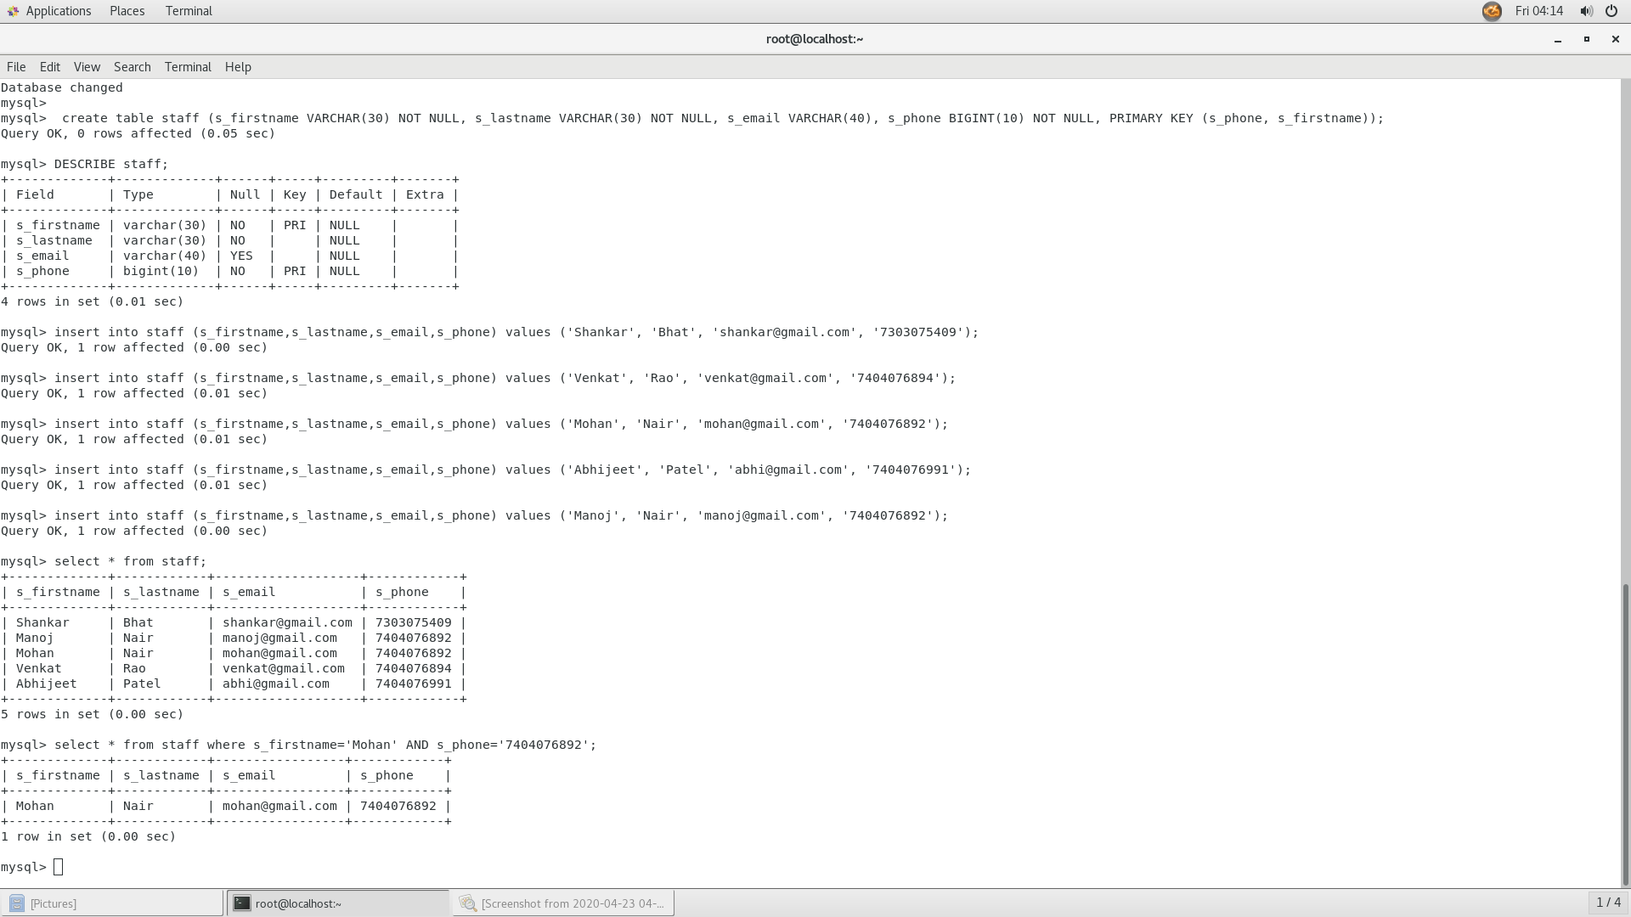

See the data within the table by using the SELECT command:

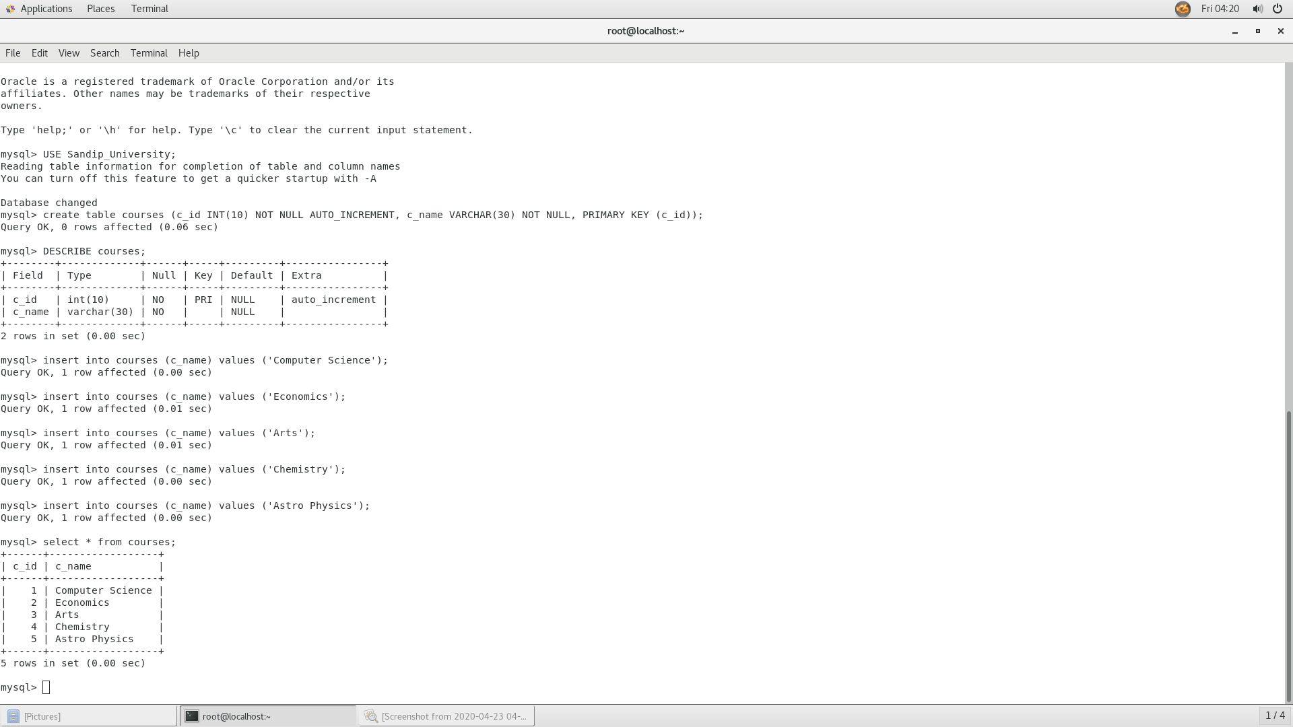



**2) UPDATE:-**

MySQL UPDATE statement is used to update data of the MySQL table within the database. In real life scenario, records are changed over the period of time. So, we need to make changes in the values of the tables also. To do so, we need to use the UPDATE statement.

The **UPDATE** statement is used with the SET, and WHERE clauses. The **SET** clause is used to change the values of the specified column. We can update single or multiple columns at a time. The **WHERE** clause is used to specify the condition, but it is optional.

Syntax:-

**UPDATE** table_name

**SET** field1=new-value1, field2=new-value2, ...

[**WHERE** Clause]

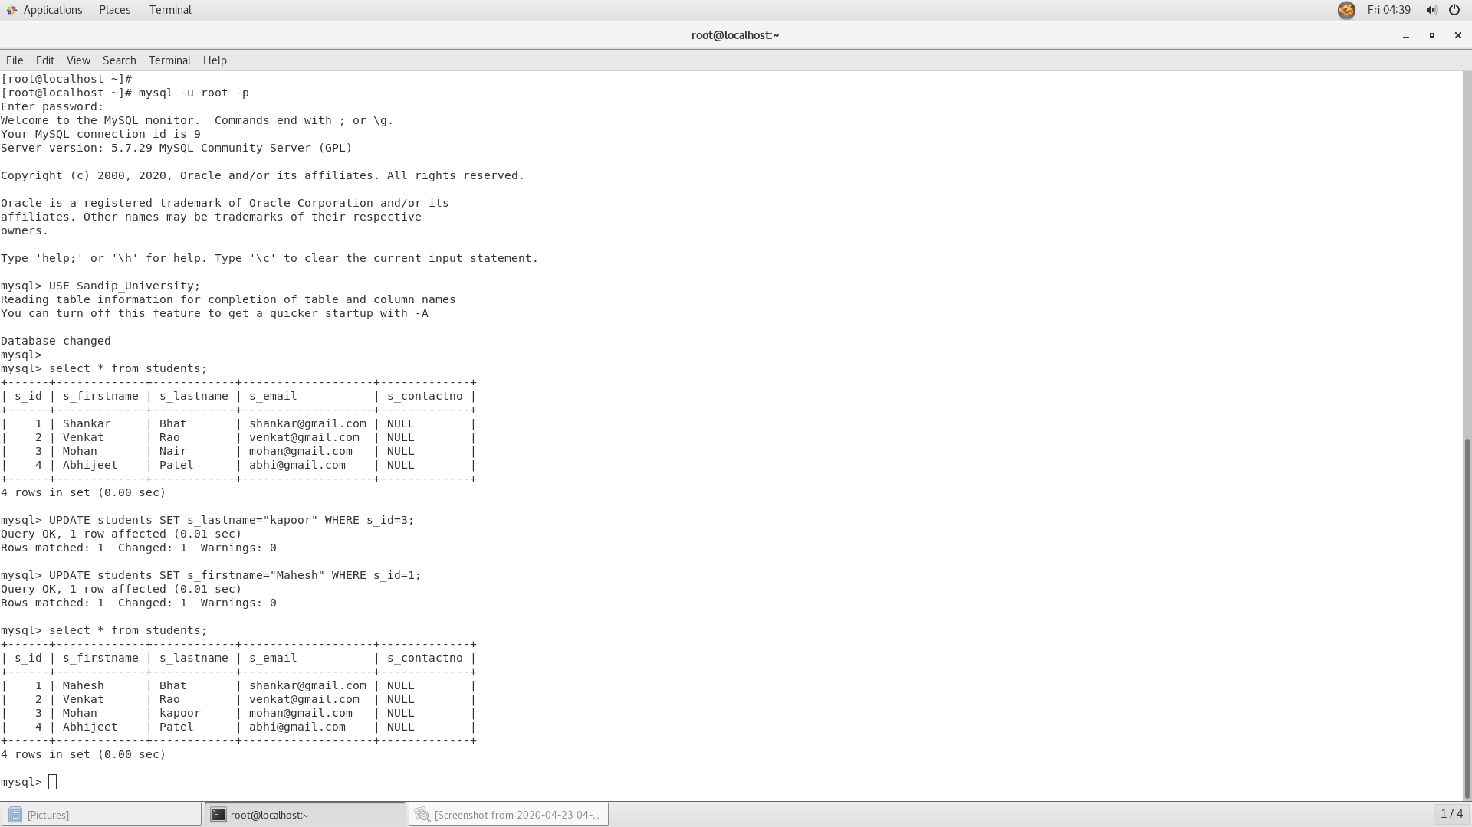

**3) ALTER:-**

MySQL ALTER statement is used when you want to change the name of your table or any table field. It is also used to add or delete an existing column in a table.

The ALTER statement is always used with "ADD", "DROP" and "MODIFY" commands according to the situation.

ADD a column in the table

Syntax:-

**ALTER** **TABLE** table_name

**ADD** new_column_name column_definition

[ **FIRST** | **AFTER** column_name ];

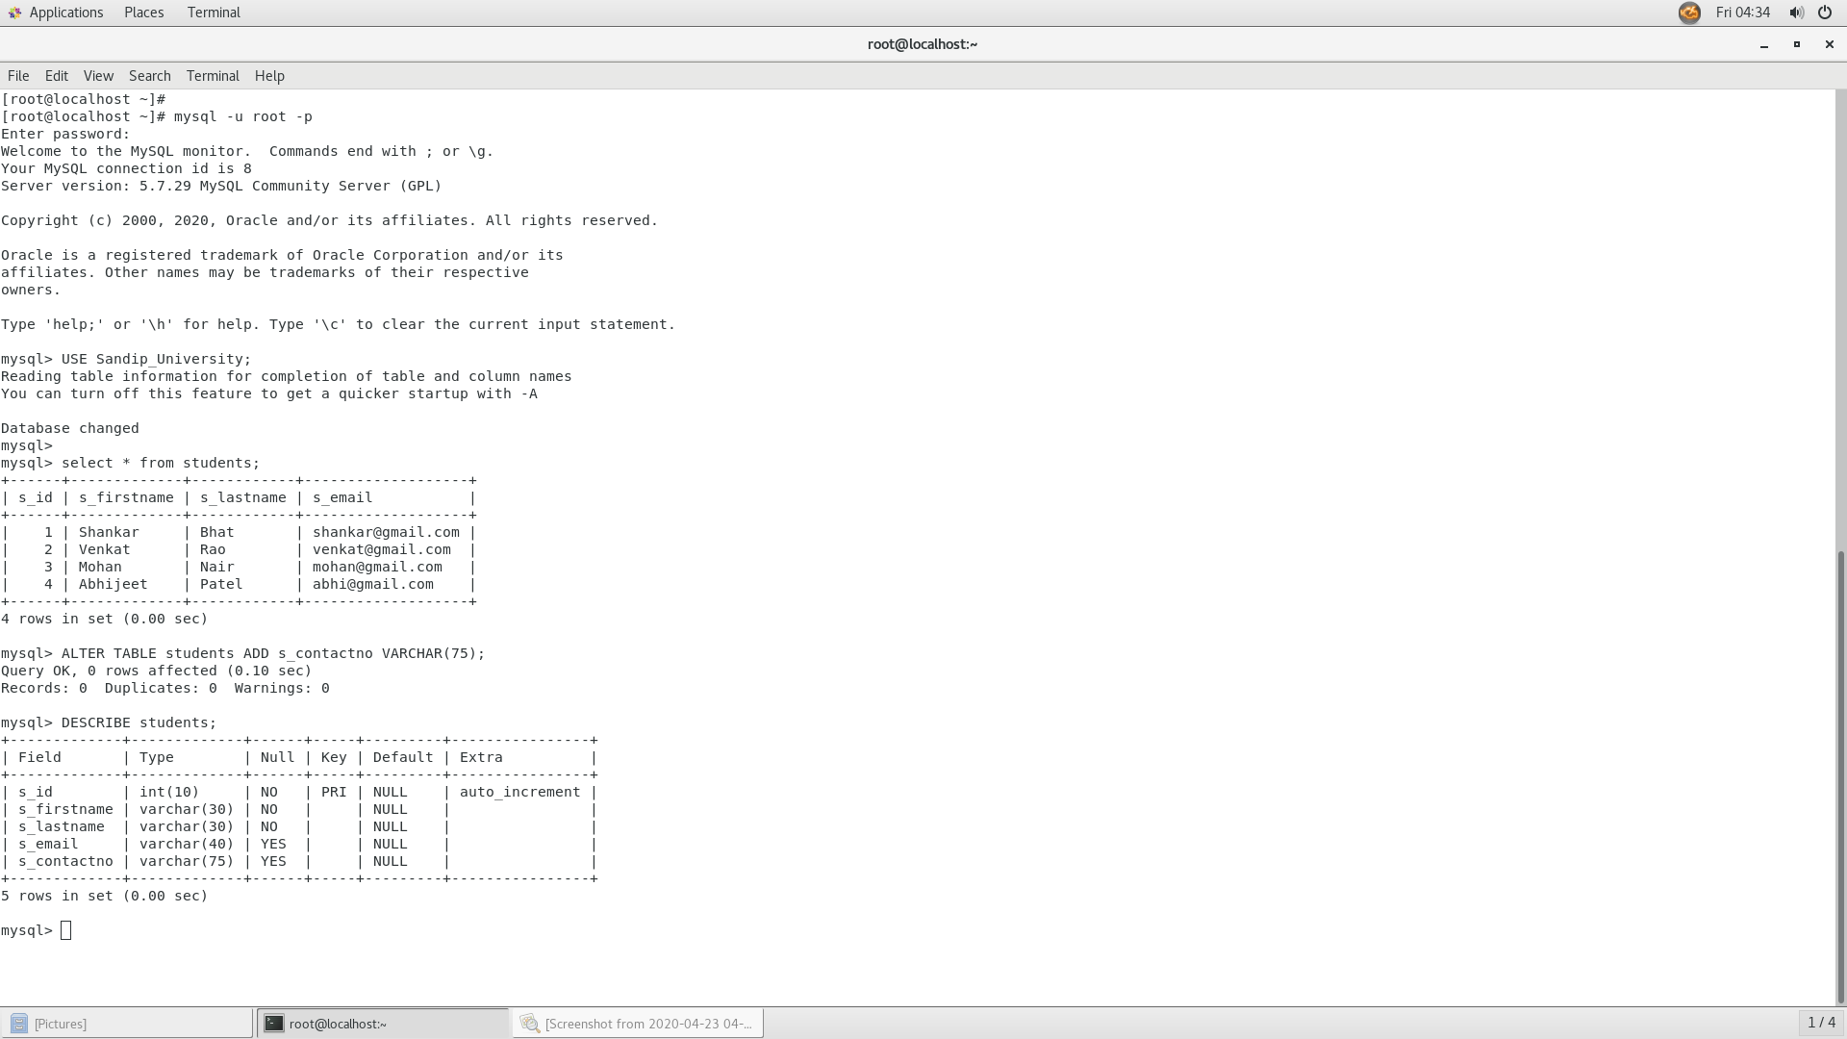

**4) SELECT:-**

The MySQL SELECT statement is used to fetch data from the one or more tables in MySQL. We can retrieve records of all fields or specified fields.

Syntax:-

**SELECT** expressions

**FROM** tables

[**WHERE** conditions];

**SELECT** * **FROM** tables [**WHERE** conditions];



**5) DELETE:-**

MySQL DELETE statement is used to delete data from the MySQL table within the database. By using delete statement, we can delete records on the basis of conditions.

Syntax:-

**DELETE** **FROM** table_name

**WHERE**

(Condition specified);

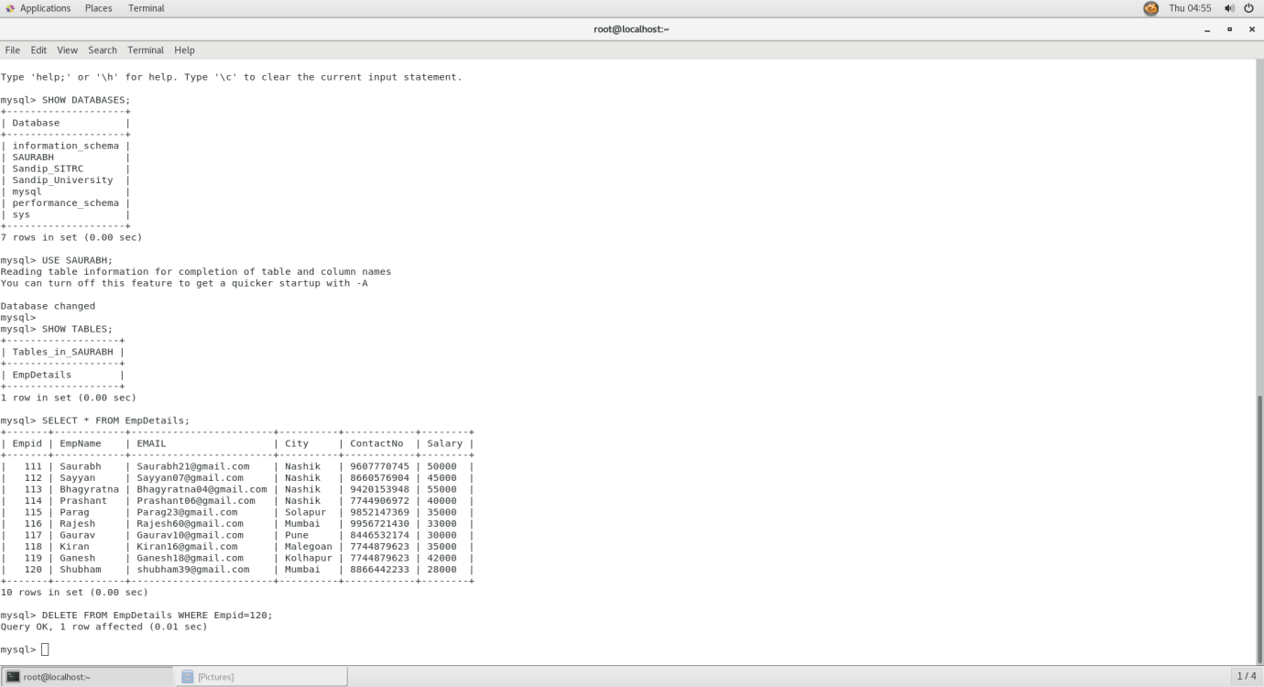

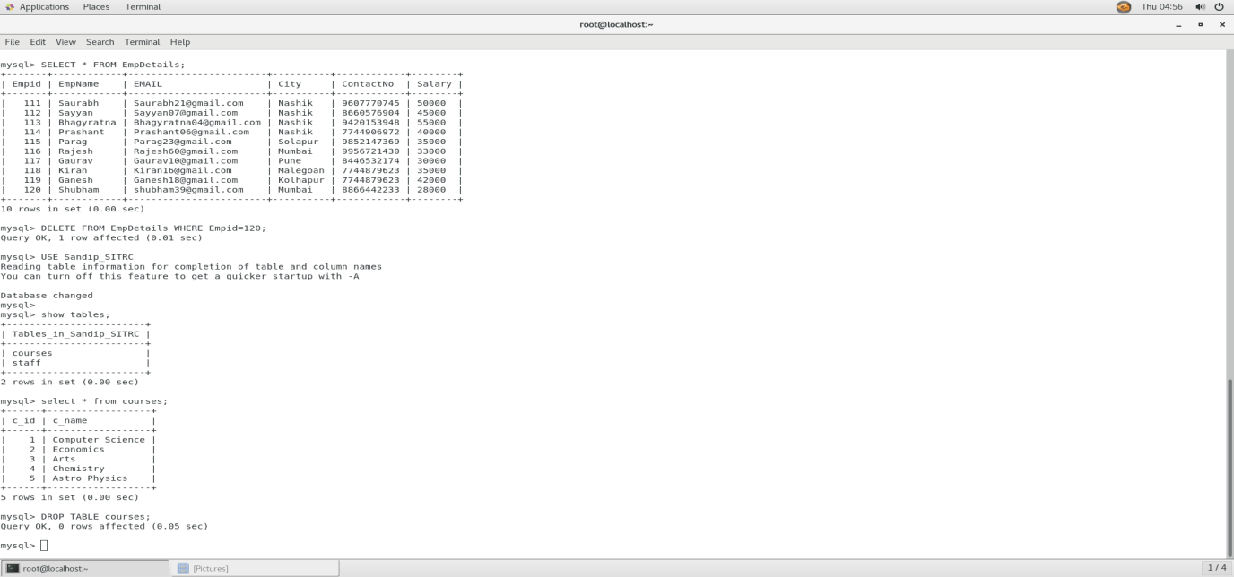

**6) DROP:-**

MYSQL uses a Drop Table statement to delete the existing table. This statement removes the complete data of a table along with the whole structure or definition permanently from the database. So, you must be very careful while removing the table because we cannot recover the lost data after deleting it.

Syntax:-

mysql> **DROP** **TABLE**  table_name;

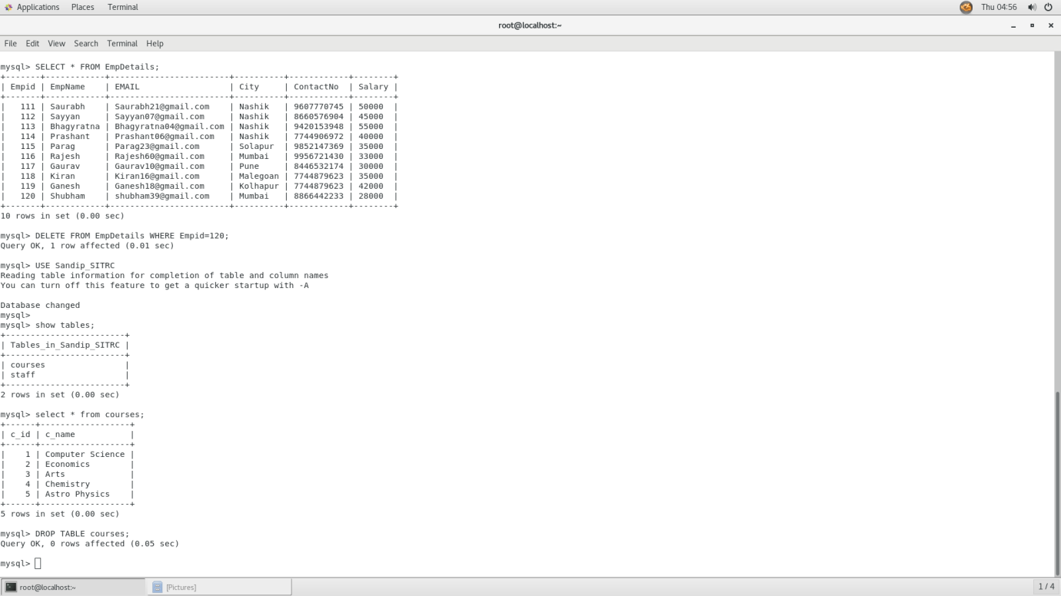

**6.A) DROP DATABASE:-**

You can drop/delete/remove a MySQL database easily with the MySQL **DROP DATABASE** command. It deletes all the tables of the database along with the database permanently. It throws an error, if the database is not available. We can use the **IF EXISTS** option with the DROP DATABASE statement. It returns the numbers of tables which are deleted through the DROP DATABASE statement. We should be careful while deleting any database because we will loose all the data available in the database.

**Syntax:**

**DROP** **DATABASE** database_name;

